Town of Swampscott
Finance Committee Meeting Minutes
Monday, July 10th, 2023 - 7:00 PM
Virtual meeting

FINANCE COMMITTEE MEMBERS PRESENT
Eric Hartmann (Chair), Joan Hilario, Cinder McNerney, Suraj Krishnamurthi, Adrian Rodriguez, Erik Schneider.

FINANCE COMMITTEE MEMBERS ABSENT
Matthew Kirschner (Vice-chair), Naomi Dreeben, Sunit Shah.

OTHER TOWN STAFF
Sean Fitzgerald, Town Administrator; Amy Sarro, Director of Admin. & Finance; Patrick Luddy, Town Treasurer/Collector; Trang Vu, Assistant Town Accountant

The meeting was called to order at 7:02 PM

Public comment
None

Review and vote on year-end shuffle

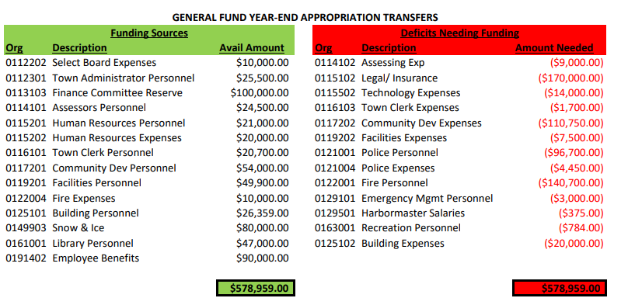

The Director of Adm. & Finance went over the accounts (in the red column) that need to be funded due to deficits during FY2023. The assessing expense is the board of Assessors needed to get an outside consultant to do valuations in anticipation of commercial disagreements where they were going to be fighting specifically in the Vinnin Square area. This is for a consultant for that we checked with KP law and was determined that it was not an allowable use of the overlay, which was the original assumption when this was done. The $170,000 in legal and insurance, of which $70,000 is for the property insurance at the Hawthorne (halfway through year update with Finance Committee and Selectboard). The other one hundred is additional legal costs through our regular town council or additional special counsel that was needed for matters.

Eric Hartman asked on the town council costs if we are concerned that we are underbudgeted FY24 if we hadn't really experienced this overrun yet or if we already know that when we planned. Amy Sarro commented that as of right now, we're not anticipating anything, and we had a number of things wrapped up in FY23.

Under Technology, Ms. Sarro said we just had a lot of subscription costs and a lot of leases we have at town hall. Our emergency response system was another big driver in FY23.

Town Clerk expenses, our town clerk had to catch up on about 10 years of town reports that had not been done. This was the cost of producing a binding just the couple copies of the town where reports that are needed for those ten years. The town report is supposed to be done every single year by the clerk's office, and it has updates from every single department, major boards, and committees, etc.....

Under Community Development expense, there is $10,750 specifically for matching grant purposes. The $100,000 of this line was the revision that went out in the email today for town wide and master planning. The Director of Community Development is writing an MAPC grant for $100,000 for the town wide master plan but the proposal for it is over $100,000. Therefore, we would be needing matching funds and it is also just to come up with more of a town-wide plan. The MAPC proposal is for $140,000, of which they are trying to get 100,000 in grant and the town would need to come up with 40,000. This discussion was had by the select board around annual town meeting with the capital, but it was already so far in the process that that couldn't really be changed. This was to address some of those town wide planning things outside of Vinnin square because the capital that was approved was exclusively for Vinnin Square. Basically, of the $100,000, $40,000 of it would be matching the $100,000 grant and the other $60,000 would be for other town wide planning.

Cinder McNerney and Eric Hartmann both commented that this is completely unusual and not what we typically do with the year-end shuffle process. Instead, it seems like it's kind of thing that we probably meant to do at Town Meeting.

Amy Sarro commented that she had spoken in depth with the Town Administrator today on this. If the Finance Committee is not comfortable with this, we have 2 options, which are either just do $40,000 which would match the MAPC grant that Community Development Director is trying to get or we could just exclude the $100,000 completely.

Responding to Ms. McNerney’s question about what grants are being applied for, Amy Sarro commented that the $10,750 was one for economic impact that helps the Anchor Food Pantry and some other smaller businesses that are around the town. The MAPC grant is specifically for the Town-wide master plan that has to be done in 2025. She also commented that it is not a urgency in this but believed that while we had tailings, it was something that was discussed and the Town Administrator feels strongly about recommending it. He also understands that there will be a high chance this will not get voted for and will go to the Special Town Meeting as an article.

Joan Hilario is not comfortable with changing the nature of what the year-end shuffle is supposed to be where we get bills that need to be paid and went over and we're moving money around to do that, not just look and see what we're planning and add this into the year-end shuffle and then use the Finance Committee Reserve for that.

For Facilities expenses, this is just an increase in energy costs. We wanted to give this buffer just because the energy bills have been trending higher.

Police Personnel was brought up back in December and January that they were trending over. The chief and his staff have worked hard with changing staffing and doing only mandatory overtime to limit the deficit. They were projected to be about 160,000 over. We are going to do a 1/12th budget with the police and fire this year to keep the managing to budget and managing those staffing level. The Town Administrator met with the captain and chief earlier today and they identified some other uses and utilizing some of our special police part time to help cover some of the means as well as to reduce the unnecessary overtime.

Town Administrator Sean Fitzgerald commented that he asked the Director Adm & Finance to have a meeting with both chiefs over the next two weeks and come up with a 1/12th budget. This will force some discipline and look at how we control cost month to month and categorize expenditures in ways that help us track any kind of deficit early.

Under Police expense, we had to do a Sergeant promotional exam this year, so we have some added expense for that.

The fire personnel were discussed early and often, same as Police. It did come in slightly better than expected, but this was mostly due to the long-term sickness and the back filling.

Under the Emergency Management personnel, this was an increase to the Emergency Management Director stipend. The contract was discussed after the budget was set for FY2023.

Harbormaster salaries were $375 additional overtime for Police staffing for the harbormaster.

$784 under Recreation personnel was for the lifeguards at the beaches. We were having trouble getting enough lifeguards to staff the beaches because other communities were paying much more, as well as paying bonuses to get people to come. Therefore, we have to increase the hourly wage on that to be able to attract enough people.

The 20,000 in building expenses were for the building inspector to get some emergency spray concrete for the wall at Mission on the Bay.

Mr. Fitzgerald commented that we are going to look at ways that we can get some of those costs recovered. He expected the final fix will be sometime over the next year, but the design is underway. Responding to Mr. Schneider’s question about the status of the wall at the Hawthorne property, Mr. Fitzgerald commented that the wall system around the Hawthorne was constructed in the 50s and 60s. They have much larger granite blocks at the base. He will have a report sometime over the next few weeks from the engineering company.

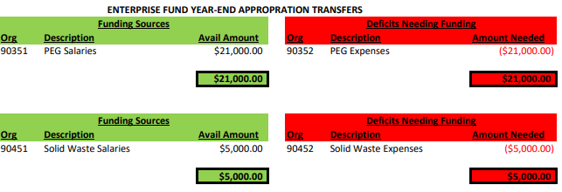

Under PEG transfers, because they didn't have as many sporting events with the schools that PEG needed to have the cable access recording, we had some savings in the salary lines. The PEG Coordinator had some upgrades that he wanted to make within this year.

For solid waste salaries, we had some extra money in the DPW overtime line, and it needed to cover the deficit in the solid waste expenses because we added some additional compost locations around town at the Senior Center.

On MOTION (Cinder McNerney) and SECONDED (Joan Hilario), it was VOTED to approve the proposed year-end shuffle, excludes the $100,000 use of Finance Committee reserve and offset that with the Community Development expenses by ROLL CALL.
ROLL CALL: Erik Schneider (YES), Suraj Krishnamurthi (YES), Adrian Rodriguez (YES), Eric Hartmann (YES).

Approval of Meeting minutes

On MOTION (Suraj Krishnamurthi) and SECONDED (Erik Schneider), it was VOTED to approve a set of meeting minutes from Apr 10th to April 13th, 2023, by ROLL CALL.
ROLL CALL: Joan Hilario (YES), Adrian Rodriguez (YES), Cinder McNerney (YES), Eric Hartmann (YES)

The meeting was adjourned at 7:45PM.

True Attest,

Trang Vu

Assistant Town Accountant

Approved by vote of the finance committee 09/19/2023.

