Town of Swampscott
Finance Committee Meeting Minutes
Joint meeting with Retirement Board
Monday, June 22nd, 2023 - 7:00 PM
Virtual meeting

FINANCE COMMITTEE MEMBERS PRESENT
Eric Hartmann (Chair), Naomi Dreeben, Cinder McNerney, Erik Schneider, Sunit Shah

FINANCE COMMITTEE MEMBERS ABSENT
Matthew Kirschner (Vice-chair), Joan Hilario, Suraj Krishnamurthi, Adrian Rodriguez

RETIREMENT BOARD MEMBER PRESENT
Thomas Driscoll (Chair), John Behen (Vice-chair), Robert Powell

RETIREMENT BOARD MEMBER ABSENT
Kevin Breen

OTHER TOWN STAFF
David Grishman, Selectboard member; MaryEllen Fletcher, Selectboard member; Sean Fitzgerald, Town Administrator; Amy Sarro, Director of Admin. & Finance; Patrick Luddy, Town Treasurer/Collector, Tracy Spear, Retirement Coordinator Assistant.

The meeting was called to order at 7:05PM

Public comment
None.

Discussion on additional 2% COLA increase

Eric Hartmann commented that there is an option for an additional 2% cost of living expense that is available to Retirement plan this year, which means there is a financial impact of this decision to the town. Even though the Finance Committee is not required to vote on it or provide the option, it is good if they can hear from the Retirement board the proposal, the costs, impact on the funding schedule, etc....

Mr. Driscoll had a summary about the background of this change is that the State legislature and Governor Baker signed a one-time bill which allows to go up for one year for a 2% increase in COLA post pandemic. The financial impact is estimated toward our actual based on actuarial hit in 2031. He mentioned the board’s effort to keep the rate of return down over the last few years and the difficulties of public sector retirees who live on low pension. The impact of this raise on them is not huge but it is helpful! He said that the COLA increase only goes to the first $14,000 base.

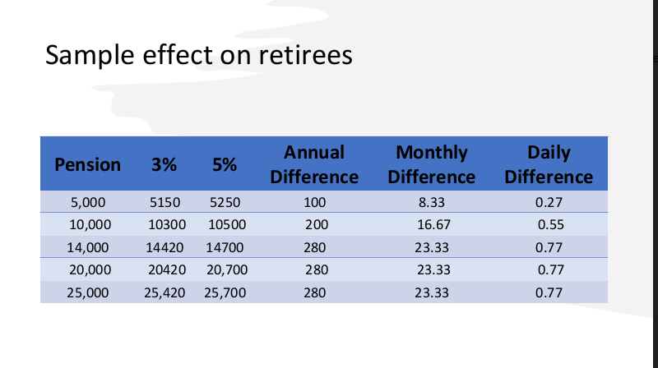
Bob Powell gave a short presentation about the Town Retirement board and the work that they have done. The board has had a history of working with the town and they have increased the funding schedule which then allows the town to have lower contribution amount. We have maintained our actuarily defined contribution (ADC) despite receiving a reprimand from PERAC. He took an example of a retiree who has today pension of $5,000 when we award them a 3% COLA which comes out of the fund, he will get $150 extra that year. Unlike Social Security where each year the base rises, the pension base in the state of MA stays the same. After the first $14,000, the retirees would only get $280 annual difference whether they are getting $100,000 pensions or $25,000 pension, that number is capped because of COLA base.

Eric Hartmann had questions on the teacher’s aide example. If we end up doing the full 5% increase, is it correct to say their base next year would be the new total of what they got this year, which is $9,914.18. (Gross annual retirement $9,442.08, after 5% COLA increase, $9,914.18). He commented that under his impression, once you get your COLA adjustment year over year, it would become the new base. In the past when we raised the COLA, we did raise the base.

Amy Sarro confirmed to Ms. McNerney’s question that there is no impact of this raise in FY2023. It is added to the end of the funding schedule, around $860,000.

Bob Powell responded that the base does not increase with the COLA.

Erik Schneider would like to confirm that base increase information and the answer from the Retirement board was that the COLAs are one-time payments that do not go into a retiree's base (both the 3% and potential additional 2%).

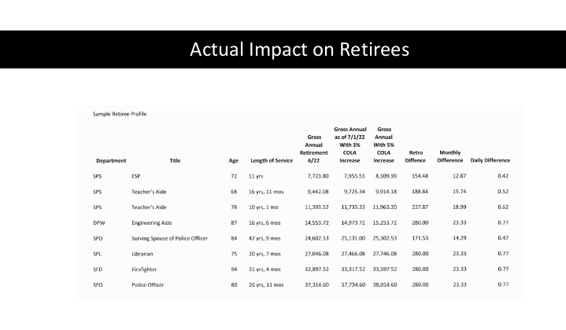

Bob Powell added that according to an article, as of the end of June 2023, 62 out of the 102 retirement systems in the state of MA and the Commonwealth have now approved the 5% increase. There are many other cities and towns which have a funded ratio lower than us, are willing to award the additional 2% despite whatever increase it might. If we increase the COLA from 3 to 5%, we will increase the July 1st, 2023 unfunded liability by $535,792 from $36,767,045 to $37,302,837. If we approve the additional 2%, it will add an ADC of $860,000 in the year 2031. He commented that this impact is minimal when you put it in perspective of what the percentage of budget that ADC represents.

Eric Hartmann commented that if we were to consider a favorable recommendation on this, it would include a thought of revisiting the funding schedule.

Erik Schneider commented that this is a cost of human capital, a benefit for former employees that have provided services to the town and does not seem right to ask someone in 2031 to pay for these benefits when they might or might not receive the services. John Behen seconded this opinion.

Bob Powell said that in his opinion, it is not uncommon for future generations to pay for bills that are incurred today because they will benefit from people who have contributed today.

Sean Fitzgerald appreciated the advocacy of the Retirement board and commented that this is a significant burden and did not see this as a step in a prudent financial future for the town.

Thomas Driscoll commented that even though Massachusetts Municipal Association was against this, they then worked in conjunction with the Governor to come up with the option of going to City Council, Mayor and Selectboard.

Cinder McNerney would like to know the reasons MMA was opposed to this bill. Sean Fitzgerald responded that they appreciate the provision but due to its considerable negative impact on municipal budget, they oppose section 52A and House Bill 701.

Naomi Dreeben commented that she feels positive about taking the recommendation of the Retirement board on the 5% increase this year. The cost of living has really increased and people on limited incomes are having difficulty paying for it. In terms of our town operating budget, we have been able to purchase a lot of open space and find money for those things that we value, and we should value our retirees. She would like to see the impact of the $860,000 broken out into many years over a longer period of time.

Cinder McNerney commented that there is a benefit of putting this cost at the end because the chart shows the cost is declining at the end and might not affect the budget significantly. In aggregate, it might have a negative effect on the town if we approve this while the amount of money received might not change retirees’ situation. The other communities which voted on this are not necessarily able to afford this.

Eric Hartmann commented that this is not an easy decision. He personally supports it but would recommend a specific feathering now.

Sunit Shah asked when the last time the additional 2% COLA was added and when the 3% COLA started. John Behen responded that it has never been done in his 28 years in Retirement board. The answer to the latter question was around the late 90s.

Erik Schneider agreed that it is a hard decision to make. While we understand the plight of retirees, we have to balance the impact on the town’s budget and future.

Cinder McNerney expressed her concern about the $150,000M unfunded liability and commented that the town has a lot to deal with going forward. We don’t know if inflation will get tamed anytime soon. Everyone is suffering the inflation together, no matter retirees or employees, we are all taxpayers. She is not in favor of rushing to make a decision and she sees both sides of this discussion.

Sunit Shah commented that he has sympathy for this situation, but he is leaning towards not supporting this. $860,000 is a large number for the town and for taxpayers. We should also look at other benefits that are provided such as health care cost which has gone up to five or more percent in multiple years in a row; the $150,000M unfunded liability, etc.... He said we should all make some sacrifices for various purposes and reasons, and we are all in somewhat of difficult circumstances.

The Retirement board voted to adjourn the meeting at 9:10PM.

Eric Hartmann encouraged Finance Committee members to join or watch the Selectboard meeting next Monday about this.

Approval of Meeting Minutes

On MOTION (Naomi Dreeben) and SECONDED (Erik Schneider), it was VOTED to approve meeting minutes from February 7th to Apr 3rd by ROLL CALL.
ROLL CALL: Cinder McNerney (YES), Sunit Shah (YES), Eric Hartmann (YES).

On MOTION (Naomi Dreeben) and SECONDED (Cinder McNerney), it was VOTED to adjourn the meeting at 9:13PM by ROLL CALL.
ROLL CALL: Erik Schneider (YES), Sunit Shah (YES), Eric Hartmann (YES).
True Attest,

Trang Vu

Assistant Town Accountant

Approved by vote of the finance committee 09/19/2023.

